ILLINOIS AMERICAN FISHERIES SOCIETY STUDENT TRAVEL GRANTS

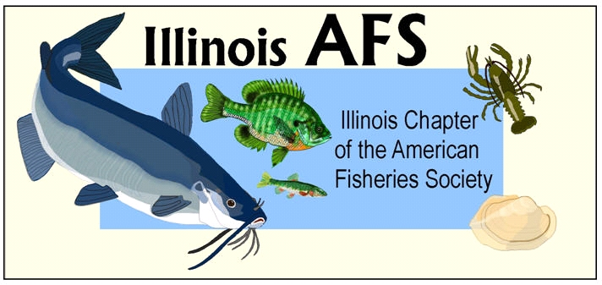

The Illinois Chapter of the American Fisheries Society (IL AFS) will be awarding up to 4 travel grants for students to attend this year’s Annual Meeting. The grants will be $100 each to help students to attend the Annual Meeting to be held at the Pere Marquette Lodge in Grafton from February 20-22, 2018.

Criteria for this selection will be based upon financial need and/or reason(s) for attending the meeting (e.g., paper presentation, pertinent paper session, IL AFS committee meeting). Students should include the above information and also state their class standing (i.e. junior, B.S. candidate), fisheries related interests, participation in IL AFS activities, and AFS membership status when applying. A letter from each applicant’s advisor confirming the need for travel money is also required.

Grant recipients are asked to attend the Business Meeting at the conference to receive their awards.

ALL STUDENTS ARE URGED TO APPLY, REGARDLESS OF WHETHER OR NOT THEY ARE PRESENTING A PAPER!!!

Submit electronic (preferred) or paper applications

by: January 26, 2018

to: Dan Grigas
IL AFS Student Concerns Committee
Forest Preserve District of DuPage County
3S580 Naperville Road
Wheaton, Illinois 60189
Phone: (630)933-7668
E-mail: dgrigas@dupageforest.org

